AdSphere
Real-Time Bidding (RTB) Advertising System
Name: Saksham Mishra
Stack: FastAPI · Python · PostgreSQL/SQLite · Redis
Roll No. 121
Problem Statement: AdSphere is a large-scale digital advertising platform similar to real-time advertising ecosystems used by
Google and Meta for serving personalized advertisements across websites and mobile applications.
Whenever a user opens a webpage or mobile app, advertisers compete in real time through automated
auctions to display relevant advertisements within milliseconds. The platform processes billions of bid
requests daily and must determine the winning advertisement instantly while maximizing advertiser
revenue and user engagement. The system faces challenges such as handling extremely low-latency
auctions, processing massive streams of user and campaign data, supporting distributed bidding engines,
preventing fraudulent traffic, and ensuring fair auction execution. The architecture must support
event-streaming systems, distributed caches, bidding engines, user profiling services, analytics pipelines,
and scalable storage infrastructure. Additionally, the system should ensure fault tolerance, high
availability, accurate targeting, and efficient campaign budget management under heavy global traffic.
Students are required to design a scalable real-time bidding system for AdSphere based on the given
scenario. They should identify system requirements, propose a distributed architecture, and explain how
bid requests are generated, evaluated, ranked, and finalized within strict latency constraints. The solution
should include storage strategies, auction mechanisms, event-processing workflows, and Python-based
implementation logic wherever applicable. Students should justify their design decisions and compare
them with real-world digital advertising systems

1. Problem Statement
In today's digital world, billions of ads are shown every second across websites and apps. Traditional advertising showed the same ad to every user regardless of age, location, or interest — wasting advertiser budgets and frustrating users with irrelevant content. There was no real-time control, no smart targeting, and no protection against bot traffic and fake clicks.
Core Problems
- Ads were irrelevant — wrong ads shown to the wrong people
- Ad budgets were wasted on users with zero interest
- No real-time control — advertisers had no way to set smart rules
- Fraud was widespread — fake clicks and bot traffic drained money
2. Proposed Solution
AdSphere is a full-stack Real-Time Bidding (RTB) platform analogous to Google Ads or Meta Audience Network, built from scratch. When a user visits a page, a silent auction runs in under 15ms — multiple advertisers compete, the smartest bid wins, and the right ad is shown to the right person instantly.
Feature | Description
Campaign Management | Create campaigns with budgets, bids, and targeting rules
Smart Targeting | Filter by age, location, and interest overlap
Real-Time Auction | Sub-15ms auction engine with full scoring
Budget Enforcement | Atomic cache-based deductions synced to DB
Fraud Protection | IP blacklist + sliding-window rate limiting
Click & View Tracking | 1×1 GIF pixel + HTTP 307 click redirect
Analytics Dashboard | Live revenue, impressions, clicks, and CTR charts

3. System Architecture
The diagram below shows how all components connect — from the client browser through fraud checks, the bidding engine, budget management, and back to the user as a winning ad with tracking URLs.
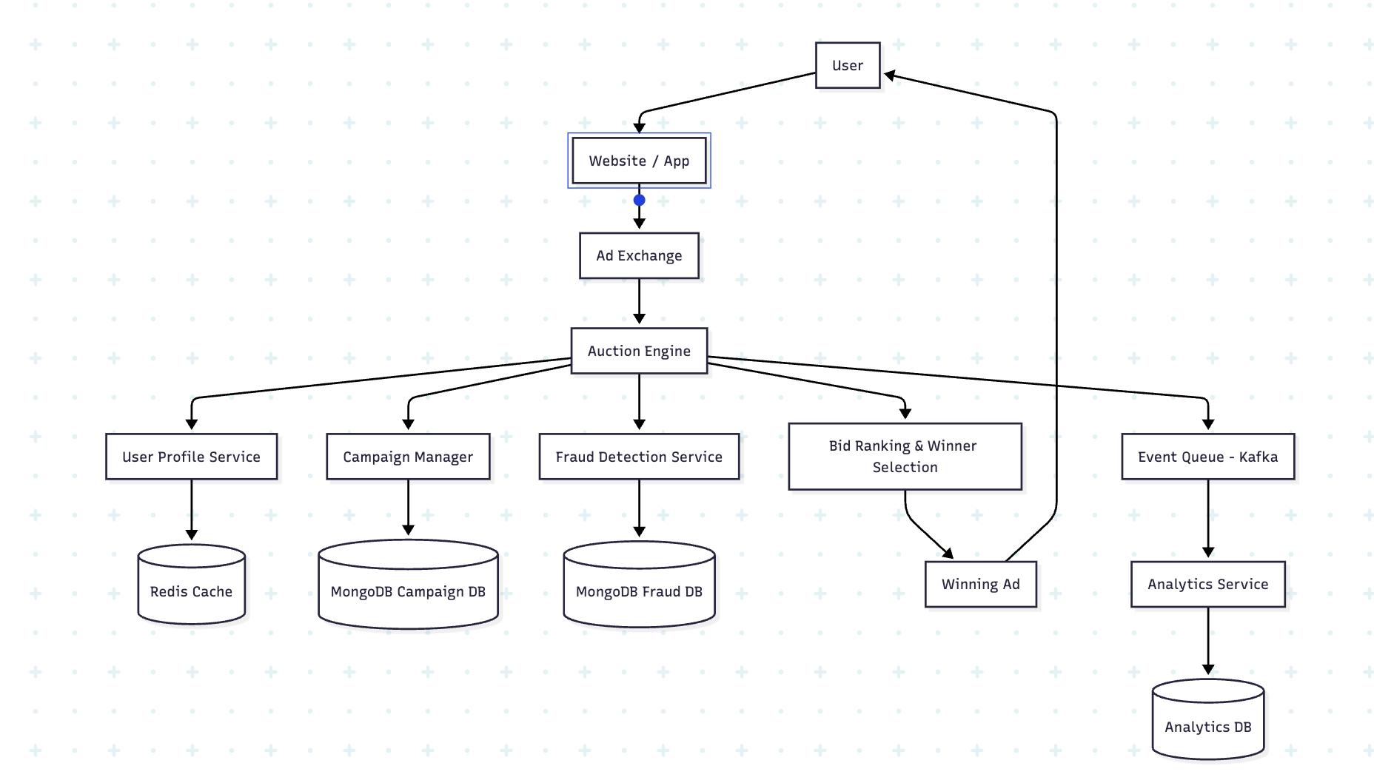
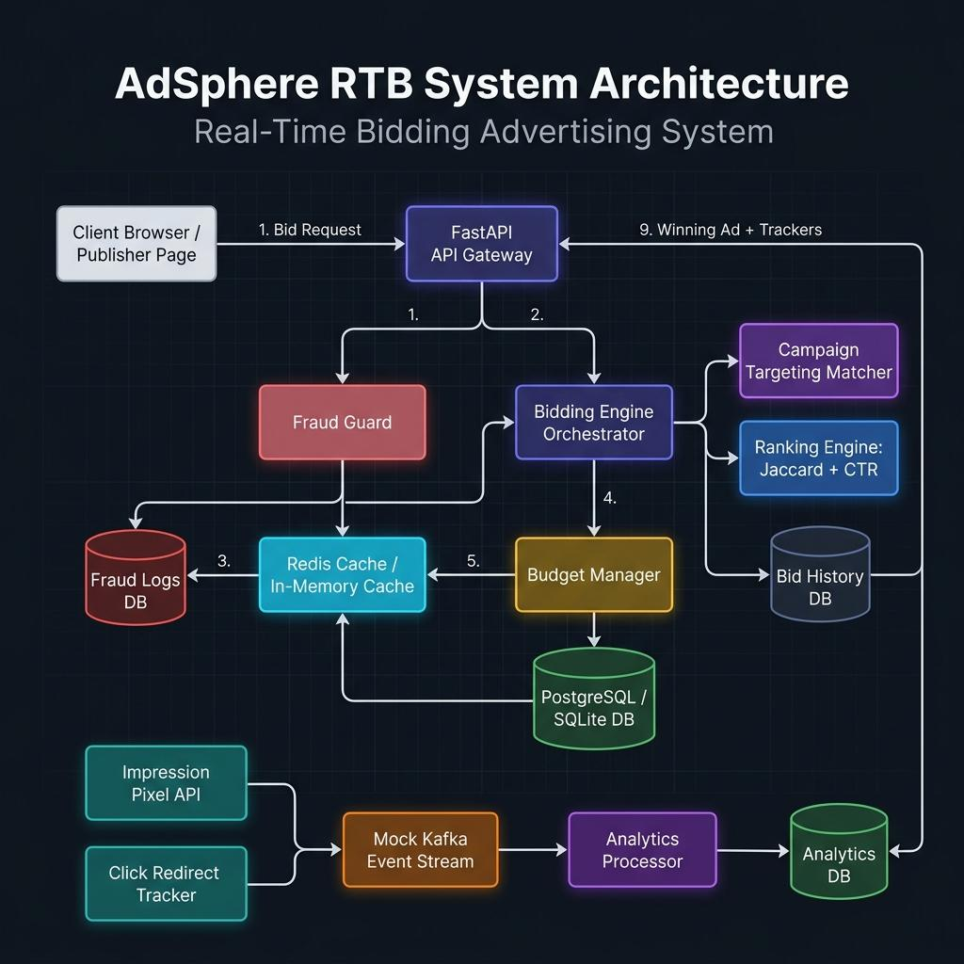
Figure 1 — AdSphere RTB System Architecture
4. Module Description
Module | File | Responsibility
FastAPI API Gateway | src/api/ | HTTP entry point — routes all REST requests
Fraud Guard | src/fraud/fraud_detector.py | IP blacklist check + rate-limit enforcement
Bidding Engine | src/bidding/bidding_engine.py | Orchestrates full auction lifecycle
Ranking Engine | src/bidding/ranking_engine.py | Jaccard similarity + Laplace CTR scoring
Budget Manager | src/bidding/budget_manager.py | Atomic spend deduction (cache → DB)
Cache Manager | src/cache/redis_cache.py | Redis client with in-memory fallback
Analytics Processor | src/analytics/analytics_processor.py | Background impression/click event handler

5. Database Design
AdSphere uses 5 SQLAlchemy ORM tables. Development uses SQLite (zero setup); production connects to PostgreSQL.
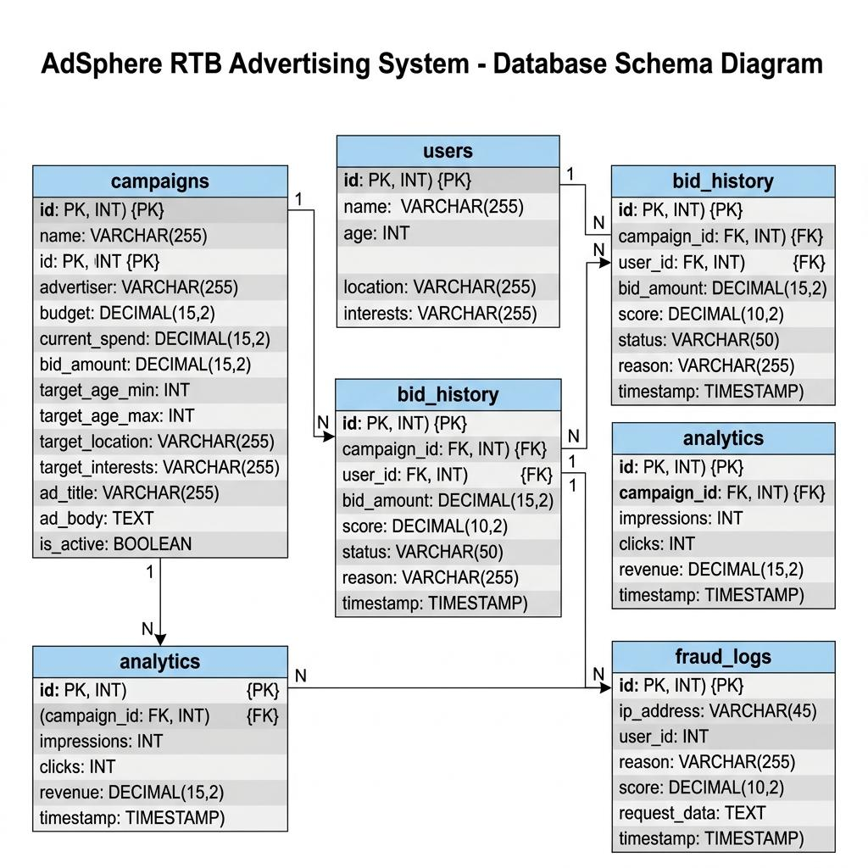
Figure 2 — AdSphere Database Schema (ER Diagram)
Table | Purpose | Key Columns
campaigns | Ad campaign definitions | id, name, budget, current_spend, bid_amount, target_*, is_active
users | Audience demographic profiles | id, name, age, location, interests
bid_history | Auction audit trail | campaign_id (FK), user_id (FK), score, status, reason
analytics | Daily performance metrics | campaign_id (FK), impressions, clicks, revenue
fraud_logs | Security event records | ip_address, reason, score, request_data

6. Technology Stack
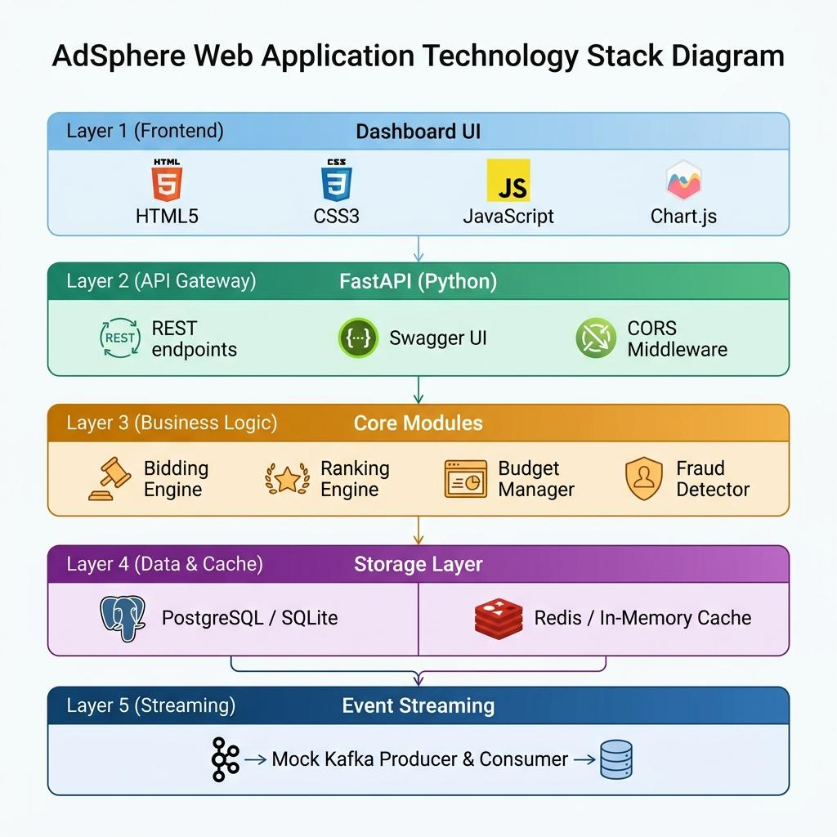
Figure 3 — AdSphere Technology Stack
Layer | Technology | Purpose
Backend API | FastAPI (Python ≥ 3.9) | Async REST API with auto-generated Swagger docs
ASGI Server | Uvicorn | Lightweight async production server
ORM | SQLAlchemy 2.0 | Python-to-SQL table mapping, no raw queries
DB (Dev) | SQLite | Zero-setup file-based database for demos
DB (Prod) | PostgreSQL | Production-grade relational database
Cache | Redis / In-Memory fallback | Sub-ms budget checks and rate limiting
Validation | Pydantic v2 | Type-safe request/response payload models
Frontend | HTML · CSS · JS · Chart.js | Dashboard UI with live charts
Event Streaming | Mock Kafka Pipeline | Simulated producer/consumer event stream

7. Implementation Details
Auction Scoring Formula
Score = Bid Amount × CTR × Relevance Score
Relevance Score — Jaccard Similarity
Interest overlap between user and campaign is measured using Jaccard Index = |Intersection| ÷ |Union|, then mapped to [0.1, 1.0] via: Relevance = 0.1 + (Jaccard × 0.9). Example: User {Tech, Gaming, Gadgets} ∩ Campaign {Tech, Gadgets} = 2/3 = 0.667 → Relevance = 0.70
Four-Stage Targeting Filter
Stage | Filter | Fail Reason Logged
1 | Budget: current_spend + bid_amount ≤ budget | FILTERED_BUDGET
2 | Age: target_age_min ≤ user.age ≤ target_age_max | FILTERED_TARGETING
3 | Location: 'All' OR matches user city | FILTERED_TARGETING
4 | Interest: ≥ 1 common interest between user & campaign | FILTERED_TARGETING

Fraud Detection
Mechanism | Threshold | Action
IP Blacklist | Exact match in blacklist | Block immediately, score = 1.0
Rate Limiting | > 10 requests / 10 seconds | Block request, score = 0.9

Caching Strategy
Cache Key | Data Stored | TTL
user:profile:{id} | Full user profile (JSON) | 10 min
campaign:spend:{id} | Current spend (float) | 1 hour
campaign:stats:{id} | Impressions + clicks | 2 min
rate_limit:{ip} | Request counter (int) | 10 sec

Key API Endpoints
Method | Endpoint | Description
POST | /auction/request | ⚡ Run a real-time bid auction
POST | /campaign | Create a new ad campaign
GET | /campaigns | List all campaigns
POST | /user | Create a user profile
GET | /analytics/summary | Aggregated analytics data
GET | /analytics/impression/{campaign_id}/{user_id} | Impression tracking pixel (1×1 GIF)
GET | /analytics/click/{campaign_id}/{user_id} | Click redirect (HTTP 307)
GET | /history | Bid history audit log
GET | /docs | Interactive Swagger UI

8. Screenshots
Overview Dashboard
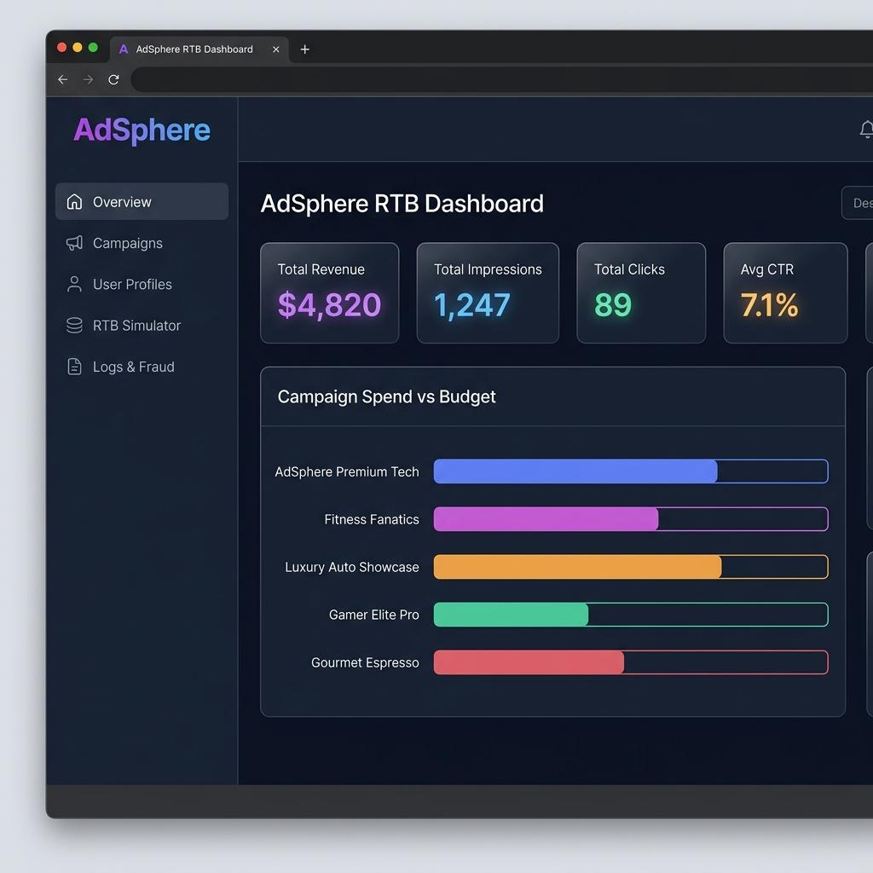
Figure 4 — KPI Cards (Revenue, Impressions, Clicks, CTR) + Campaign Spend Chart
Bid History & Fraud Log
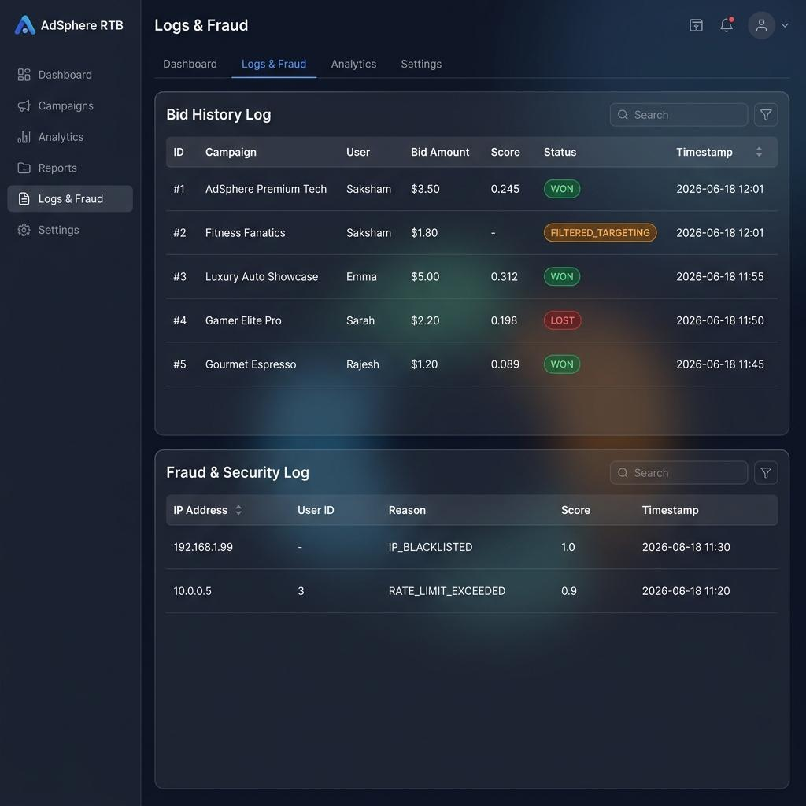
Figure 5 — Auction Bid History (WON/LOST/FILTERED) and Fraud Security Events
Auction Flow Diagram
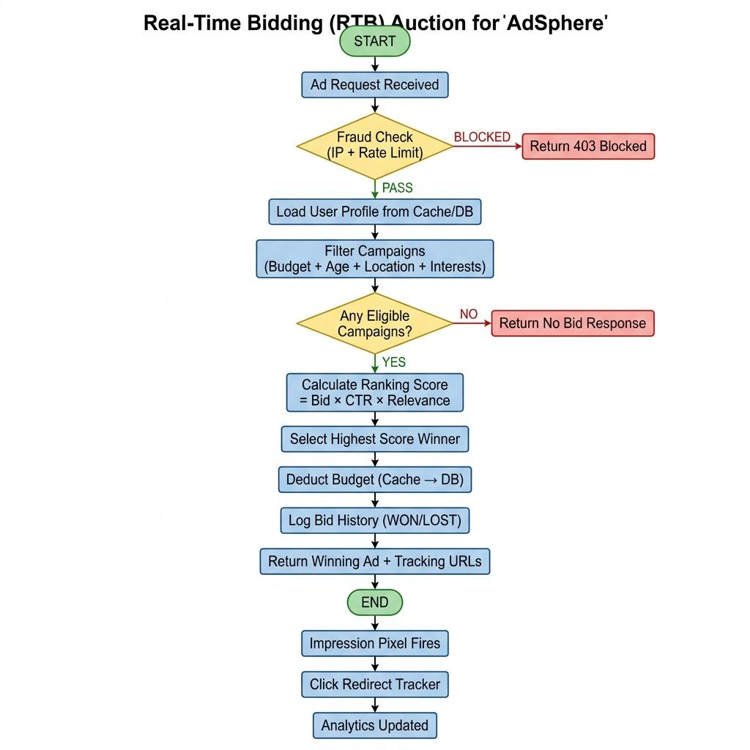
Figure 6 — RTB Auction Flowchart
Q2) System Architecture

Q3) Auction Workflow
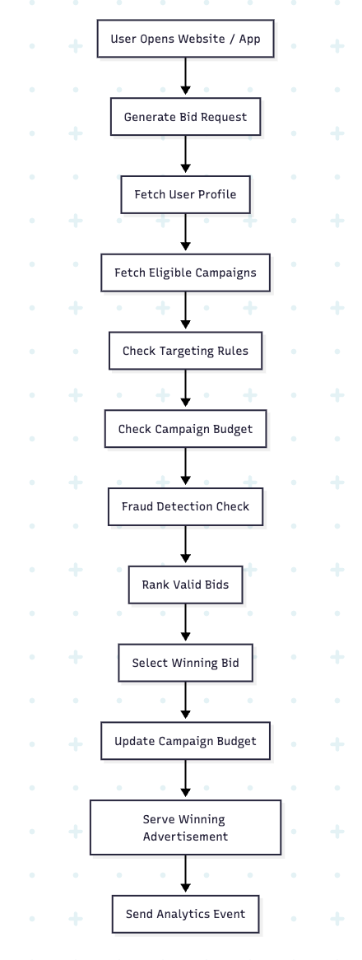
Q4) ER Diagrams
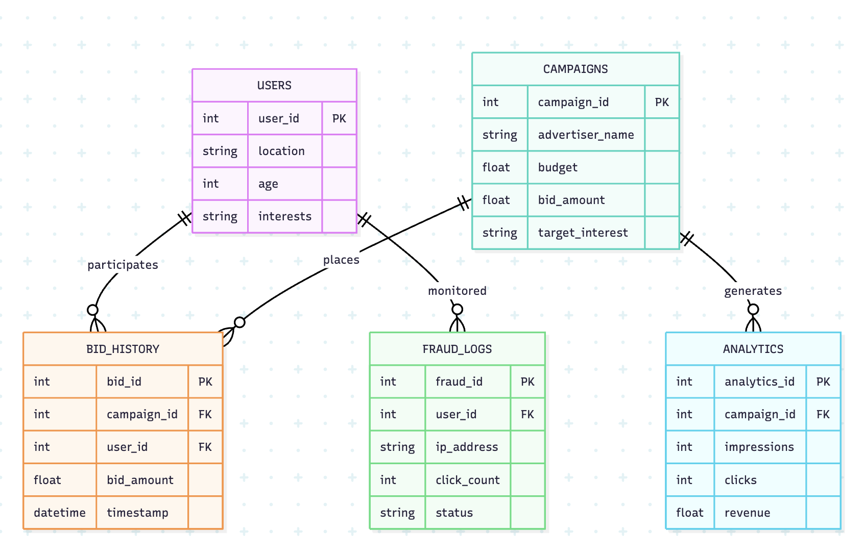
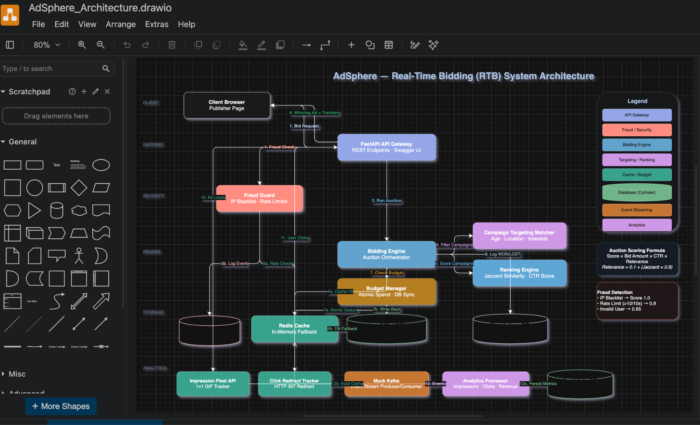

9. Future Scope
Enhancement | Description
ML Bid Optimization | Replace static formula with XGBoost/neural net for optimal bid prediction
OpenRTB 2.6 Compliance | Connect to real SSPs/DSPs using the industry-standard bid protocol
Second-Price Auction | Implement Vickrey auction — winner pays 2nd-highest bid + $0.01
Real Kafka Integration | Replace mock pipeline with Apache Kafka for production event streaming
Docker Deployment | Containerize all services (API, DB, Redis, Kafka) with docker-compose
Multi-Format Ads | Add banner, video pre-roll, and native ad formats (CPM/CPC/CPV pricing)
A/B Testing | Split ad creative traffic automatically and measure performance
JWT Authentication | Multi-tenant login so each advertiser manages only their own campaigns
IP Geolocation | Auto-detect user city from IP using MaxMind GeoIP — no manual input
Real-Time Alerts | Email/Slack alerts when fraud spikes or budget exhaustion is near

— End of Document —
AdSphere RTB System | College Capstone Project | June 2026

